**Clasificando Datos**

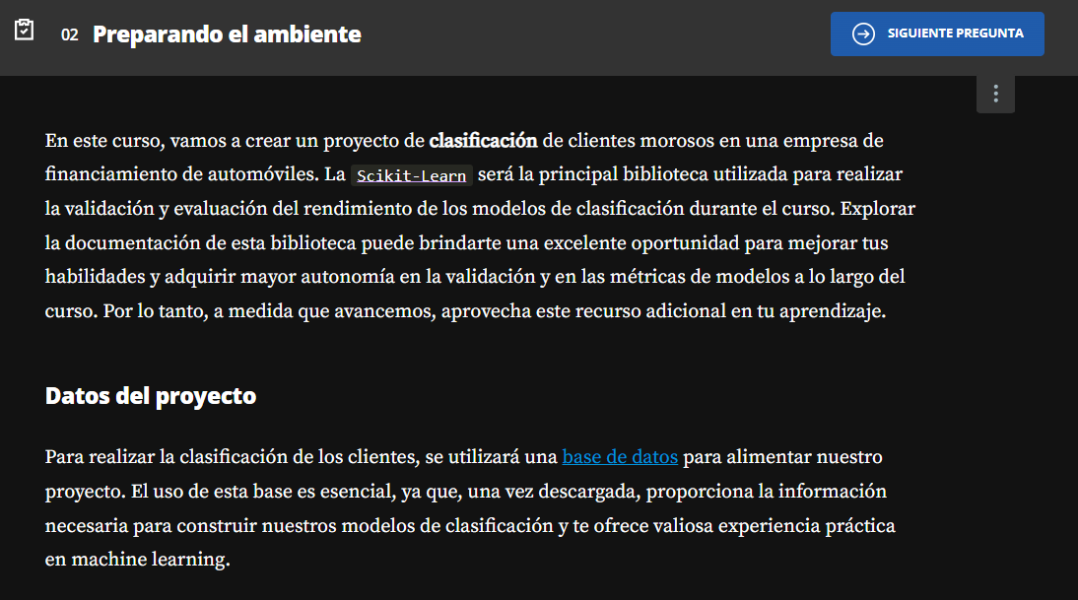

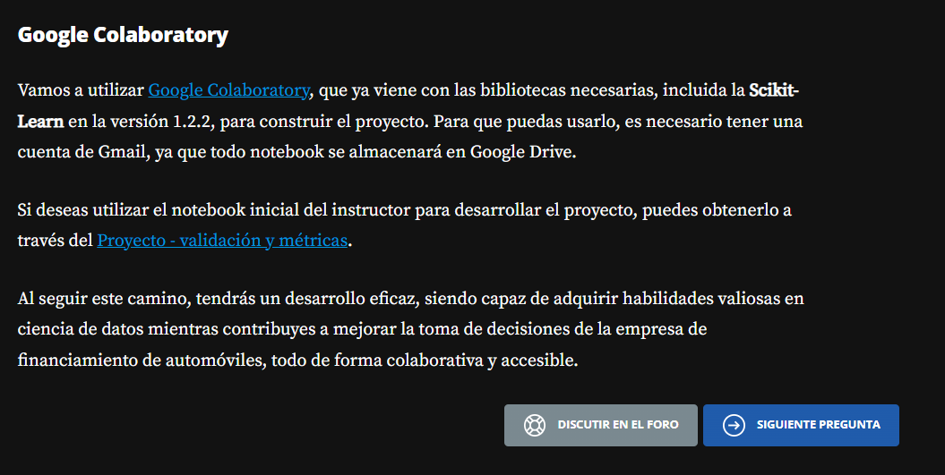

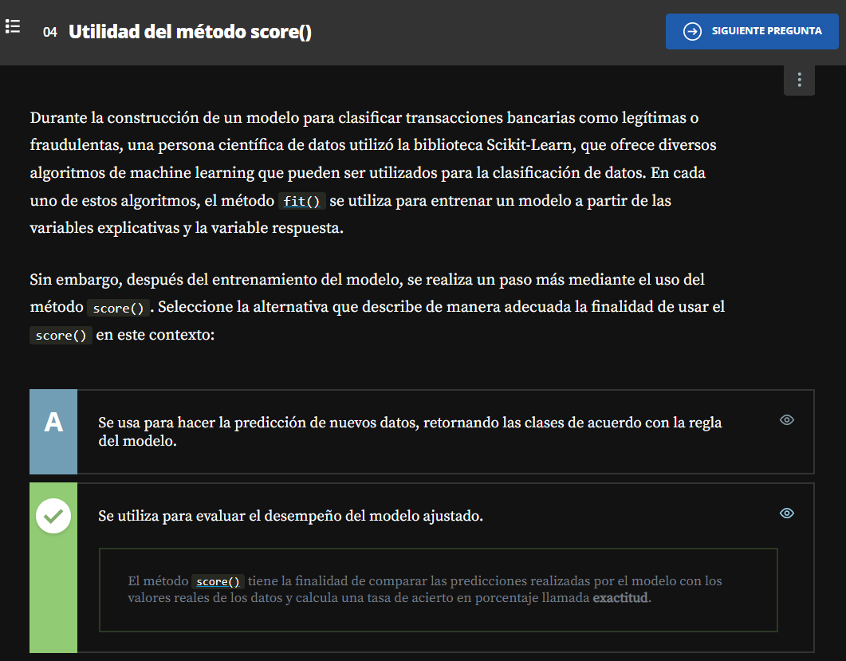

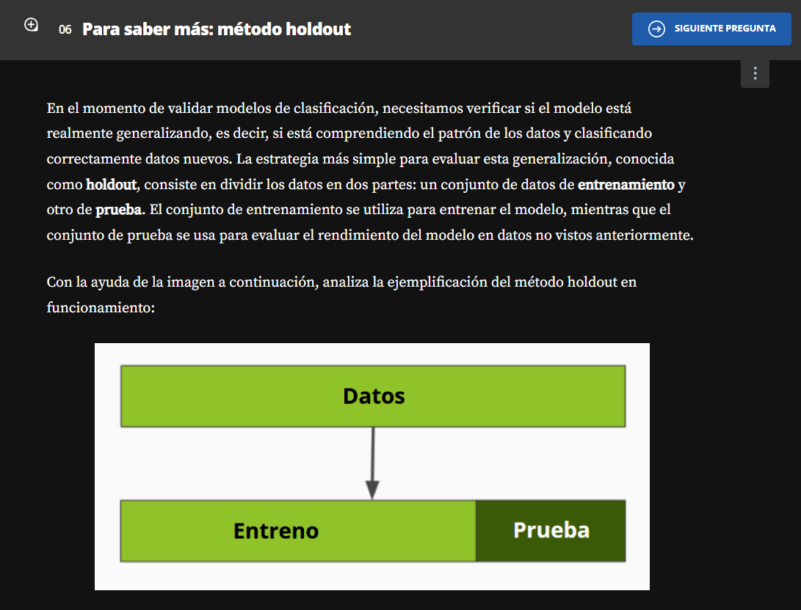

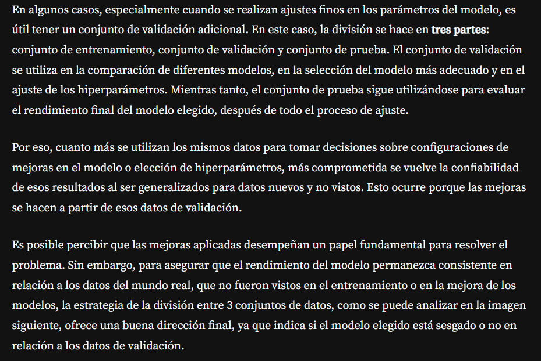

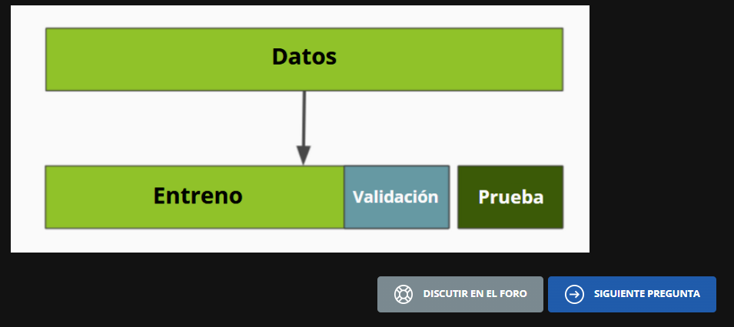

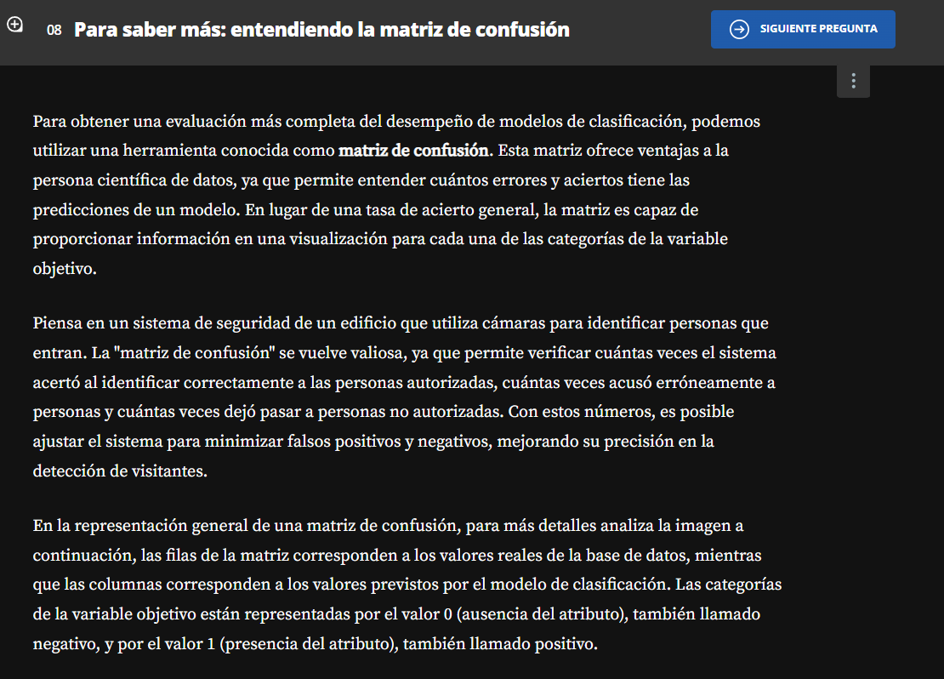

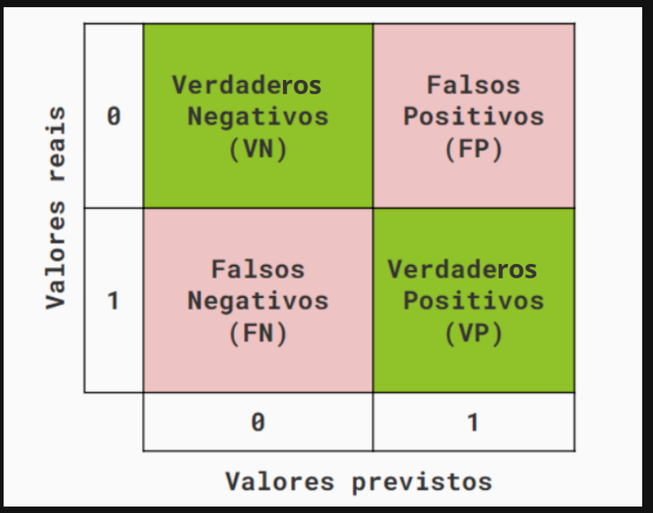

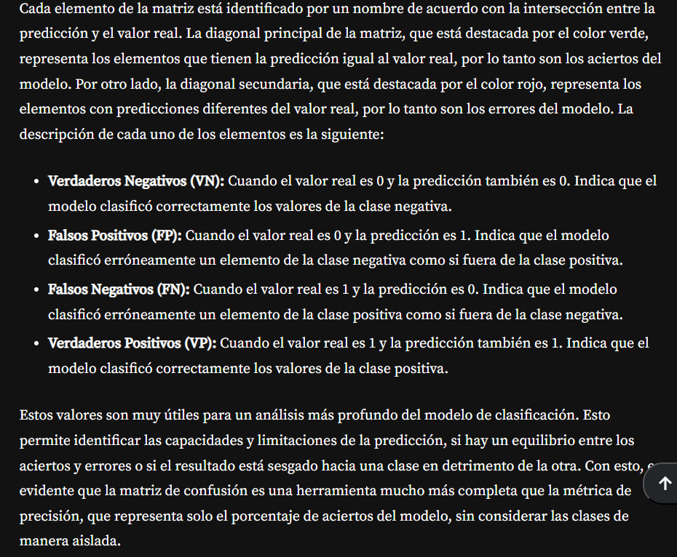

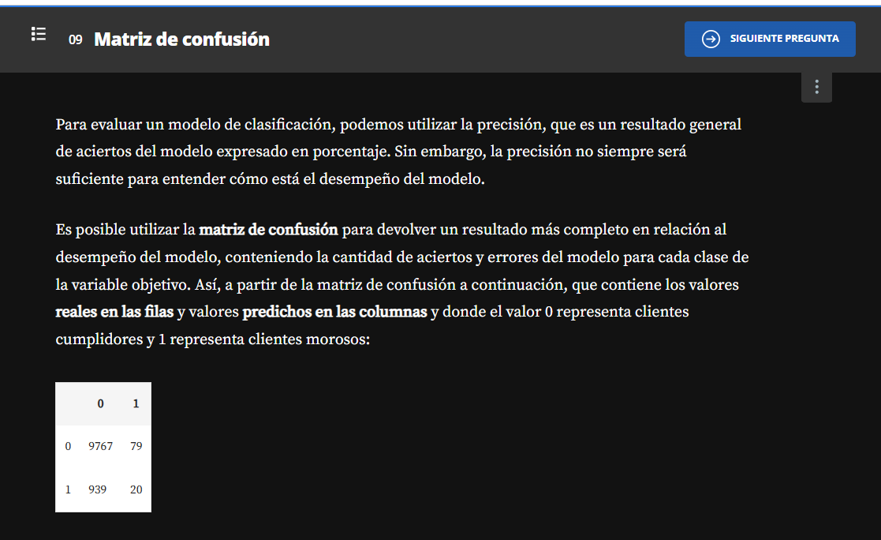

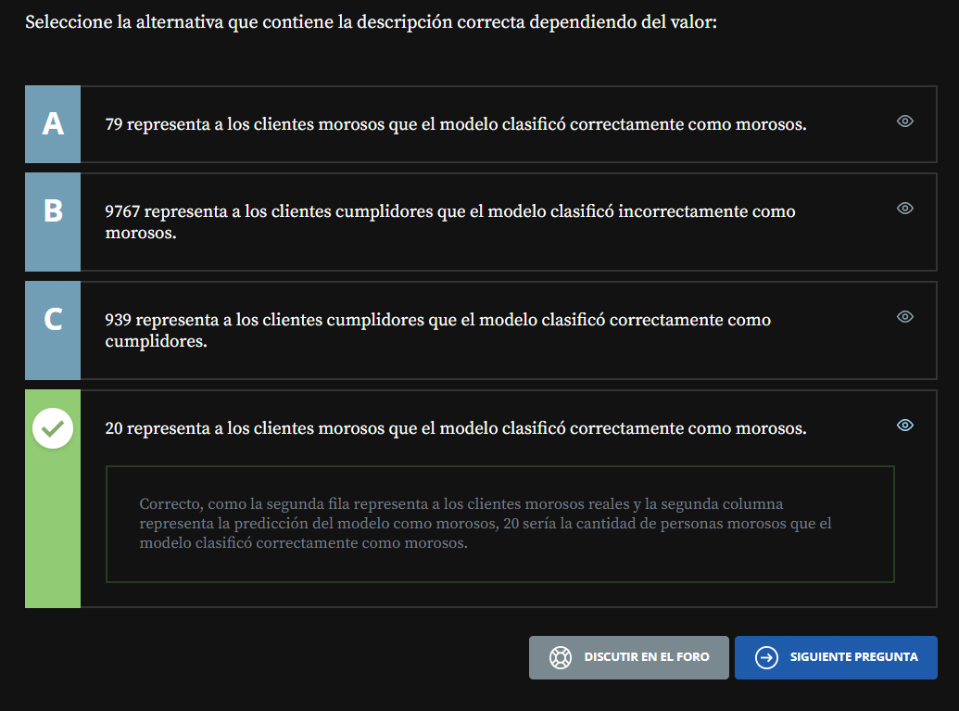

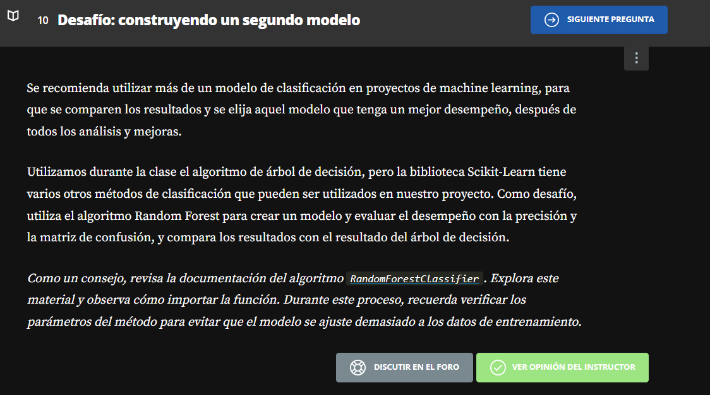

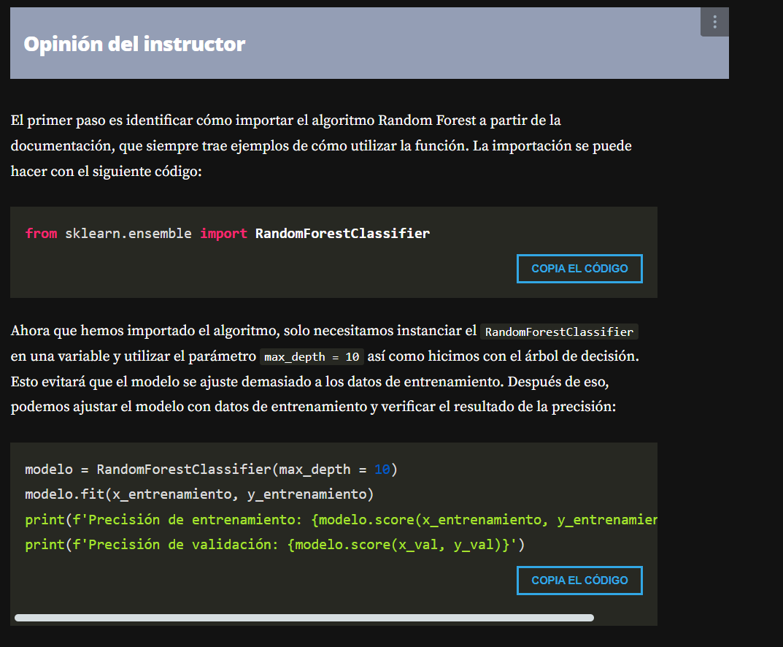

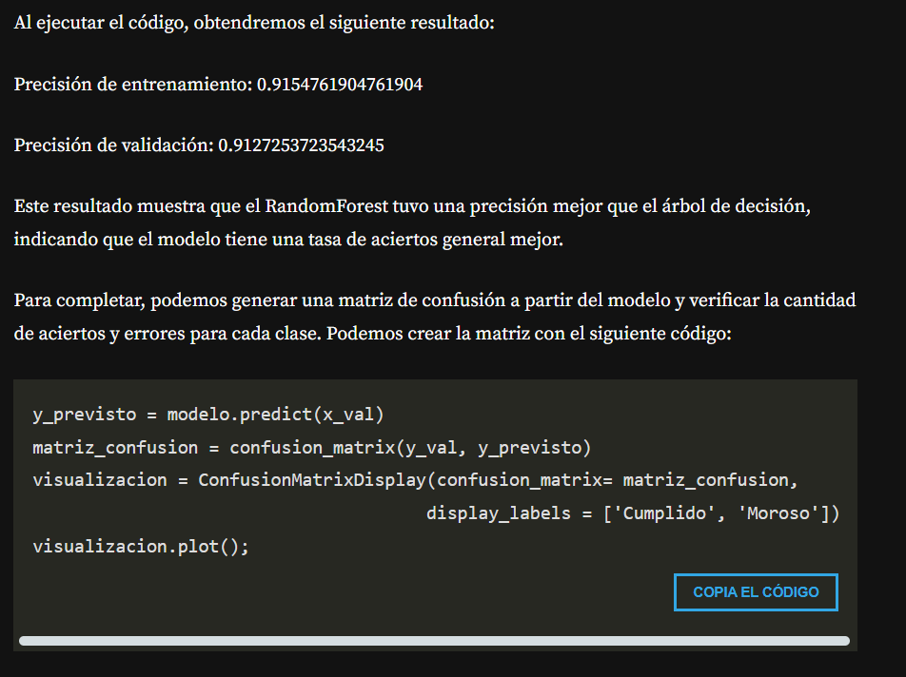

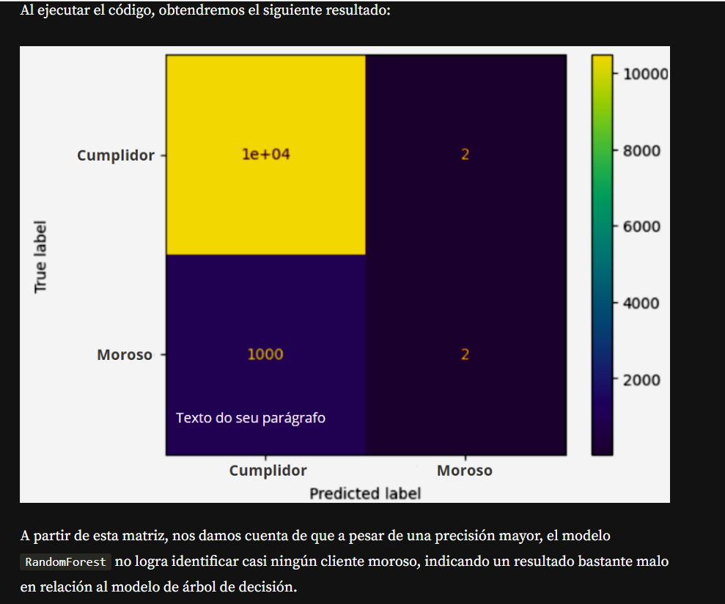

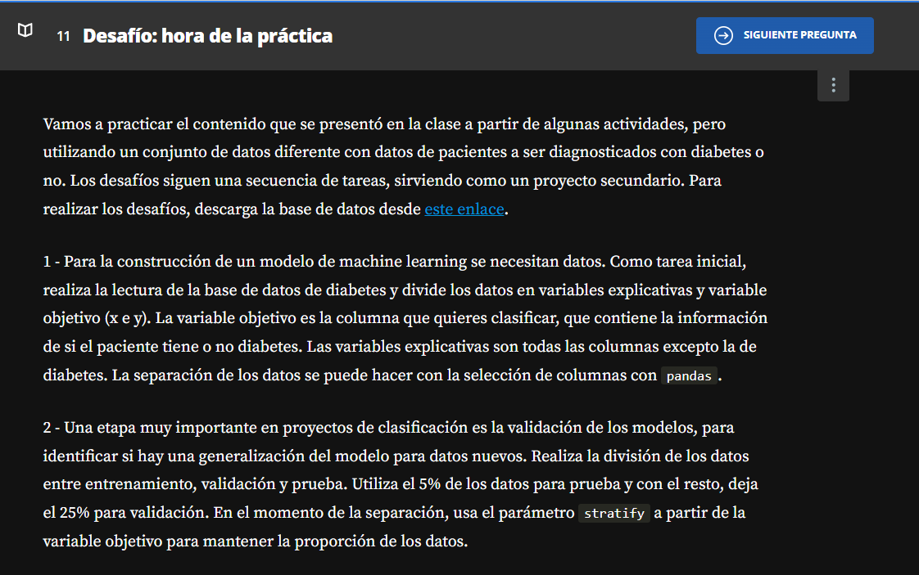

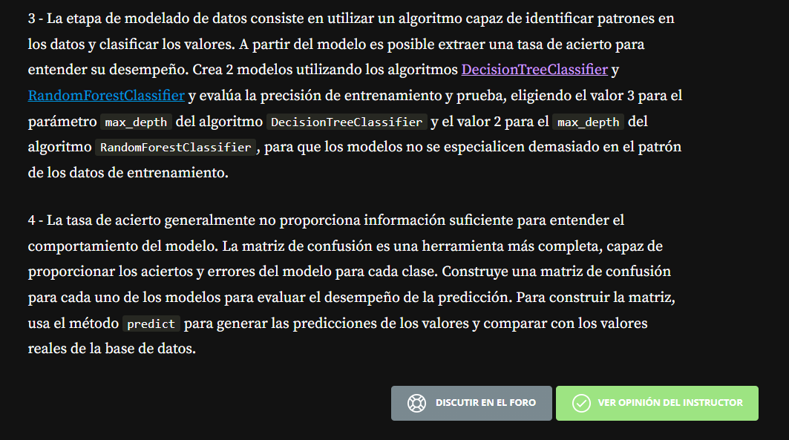

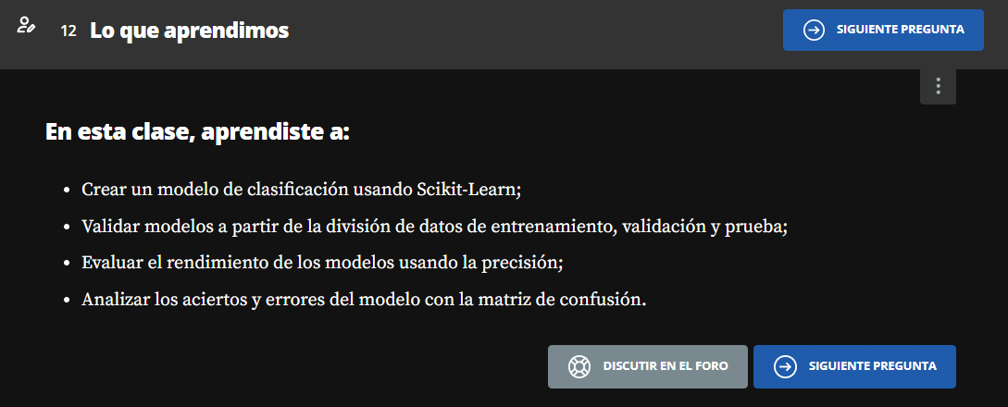

**Metricas de Evaluación**

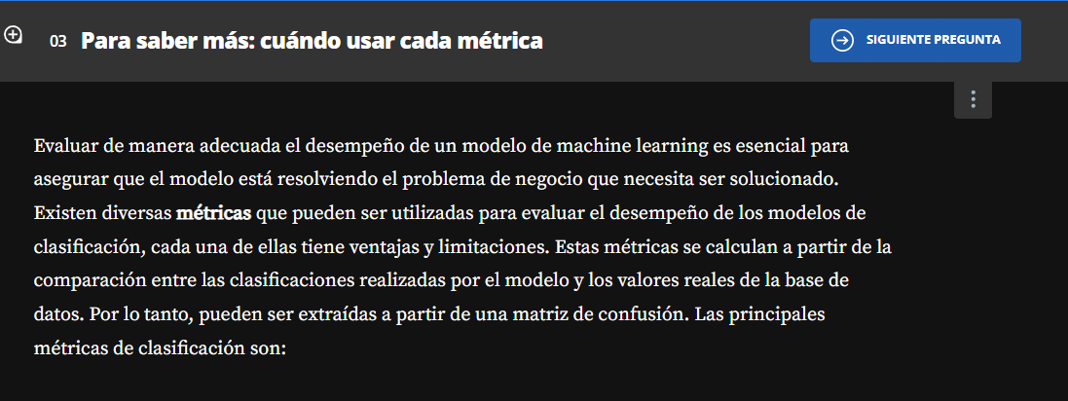

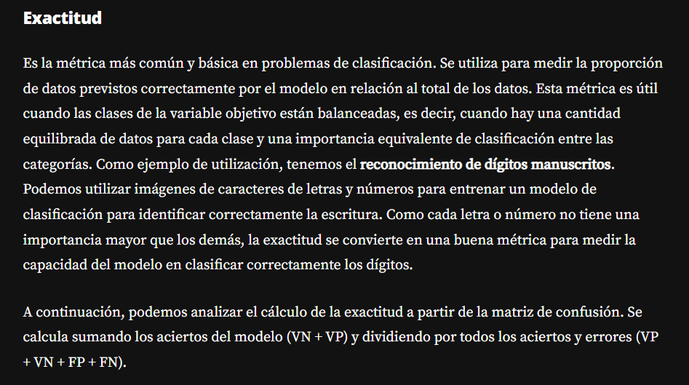

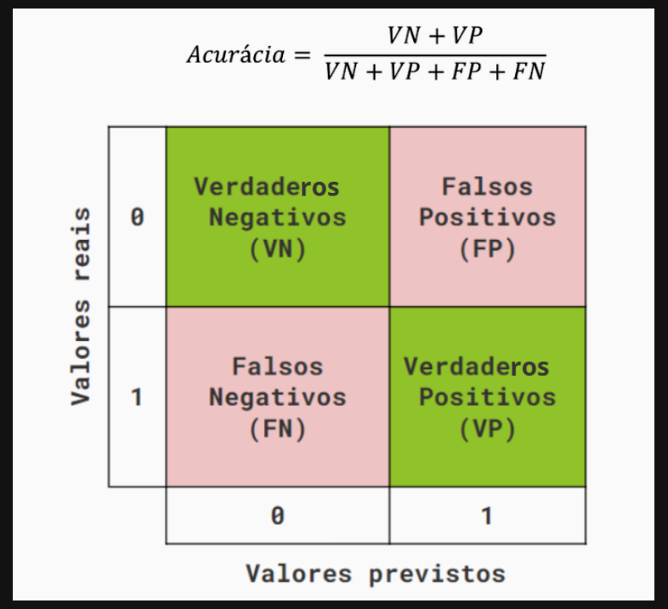

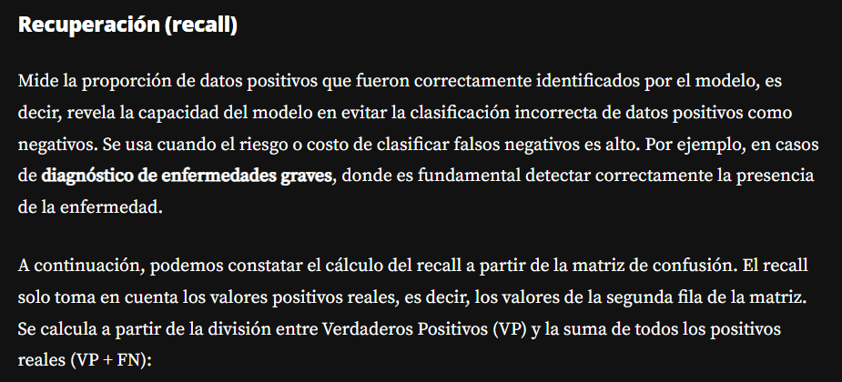

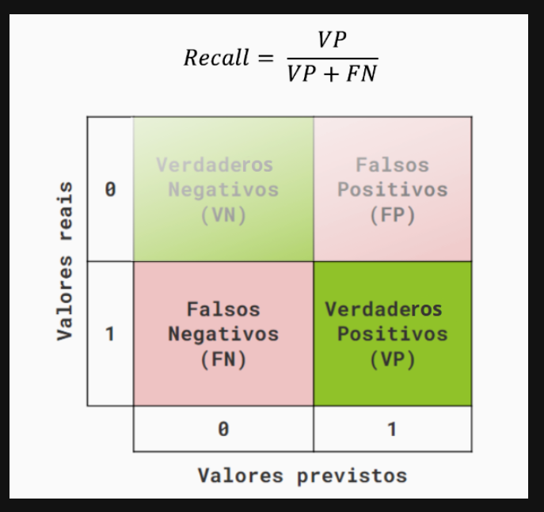

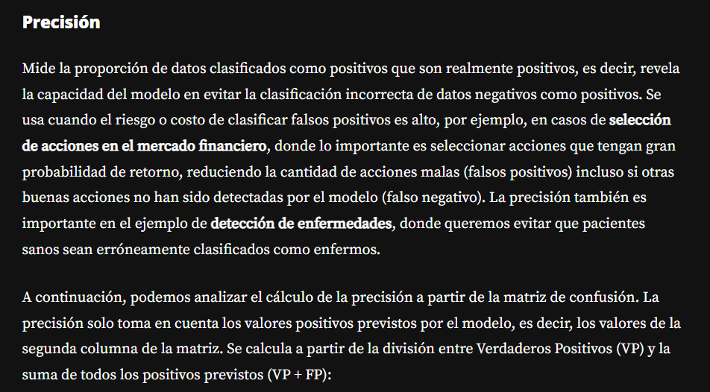

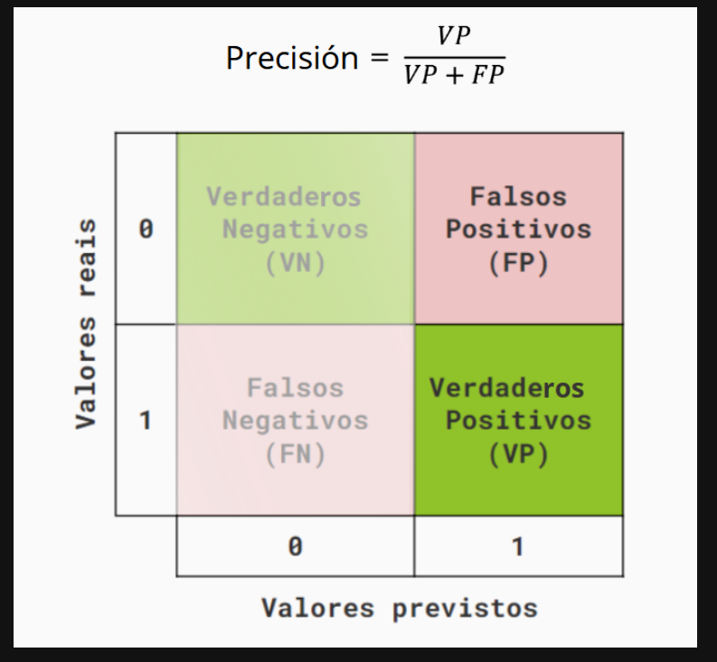

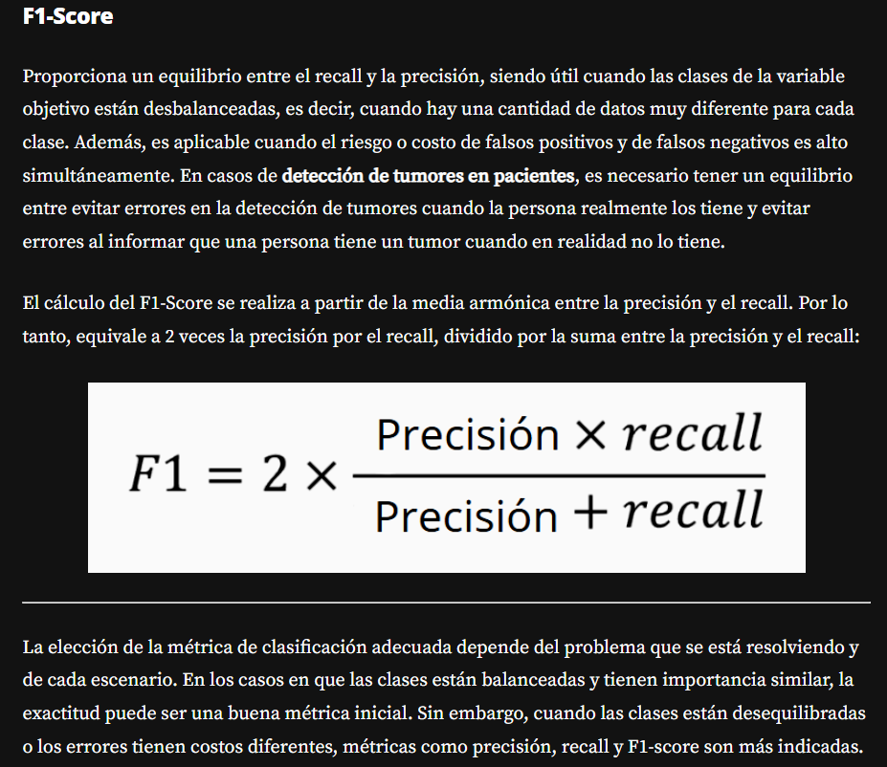

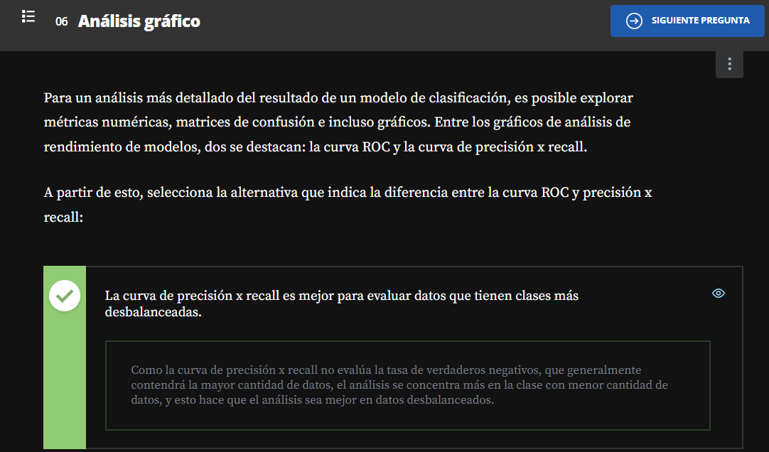

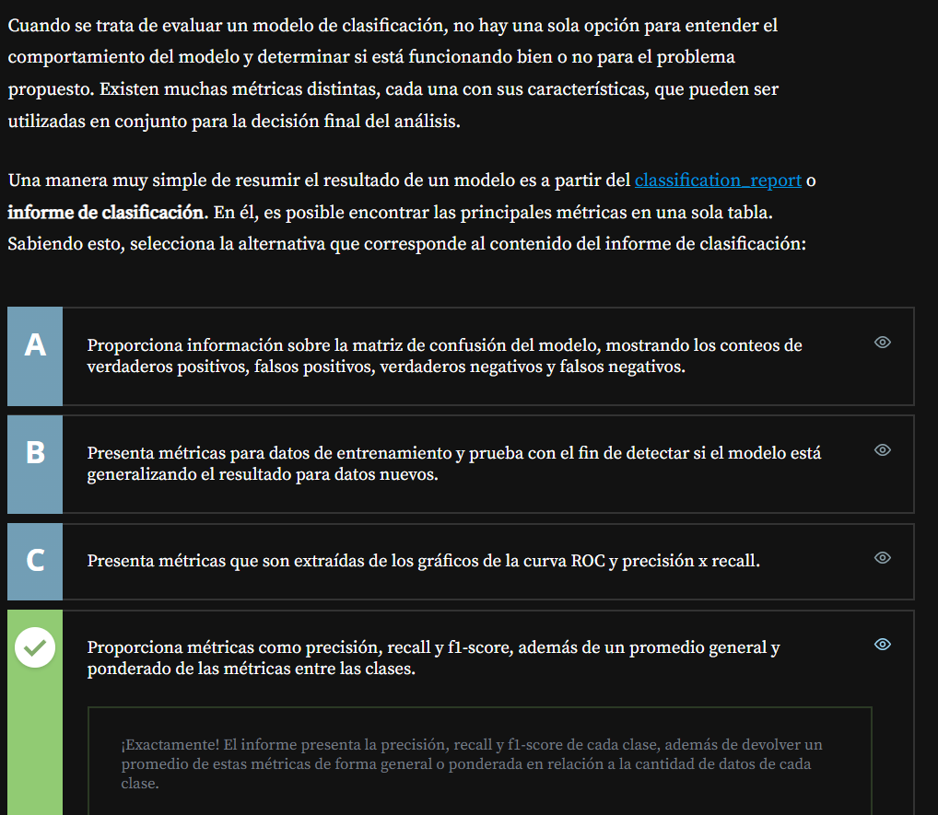

[**https://scikit-learn.org/stable/auto_examples/release_highlights/plot_release_highlights_0_22_0.html#new-plotting-api**](https://scikit-learn.org/stable/auto_examples/release_highlights/plot_release_highlights_0_22_0.html#new-plotting-api)

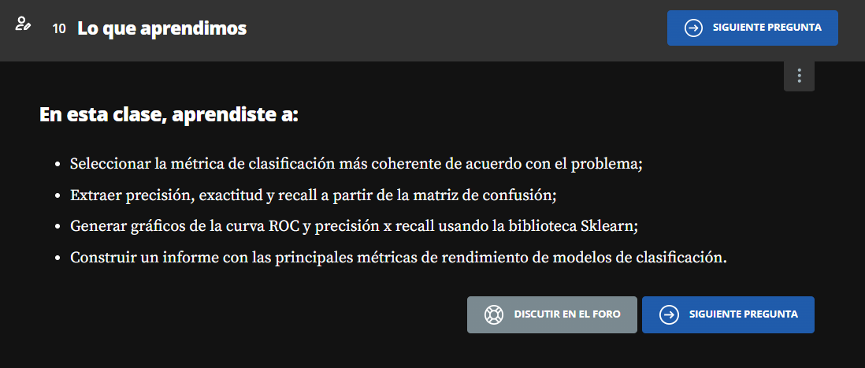

**Validación Cruzada**

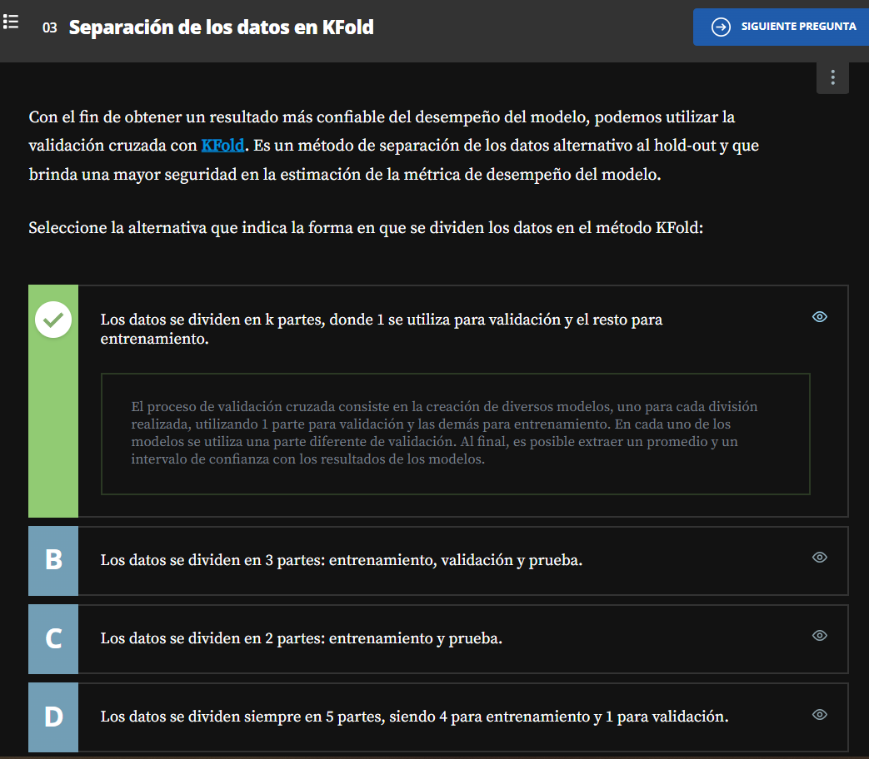

[**https://scikit-learn.org/stable/modules/generated/sklearn.model_selection.KFold.html**](https://scikit-learn.org/stable/modules/generated/sklearn.model_selection.KFold.html)

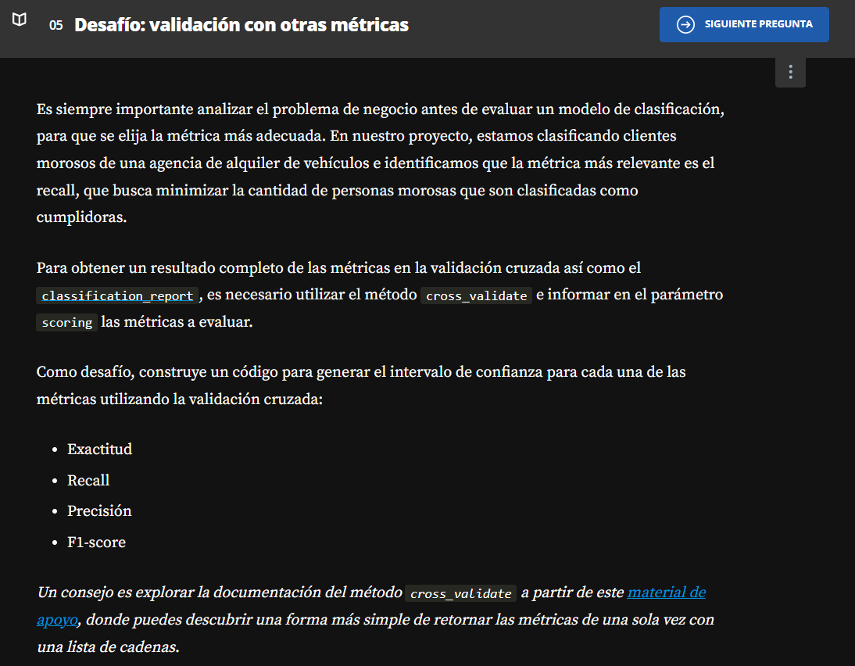

[**https://scikit-learn.org/stable/modules/generated/sklearn.model_selection.cross_validate.html#sklearn.model_selection.cross_validate**](https://scikit-learn.org/stable/modules/generated/sklearn.model_selection.cross_validate.html#sklearn.model_selection.cross_validate)

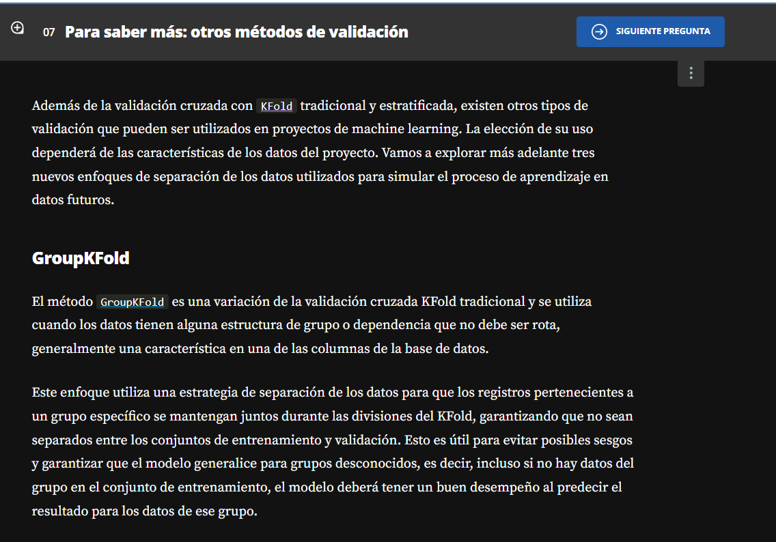

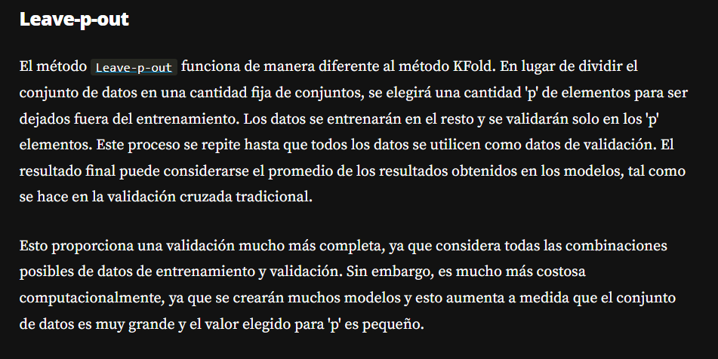

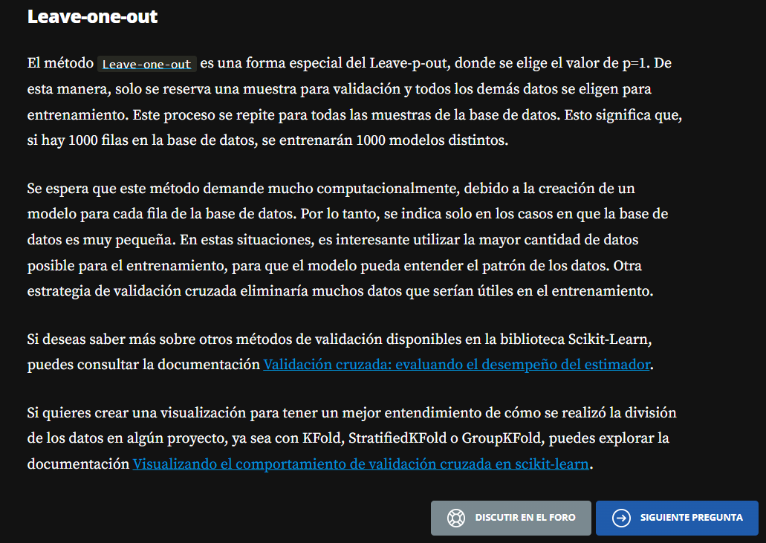

<https://scikit-learn.org/stable/modules/cross_validation.html>

<https://scikit-learn.org/stable/auto_examples/model_selection/plot_cv_indices.html>

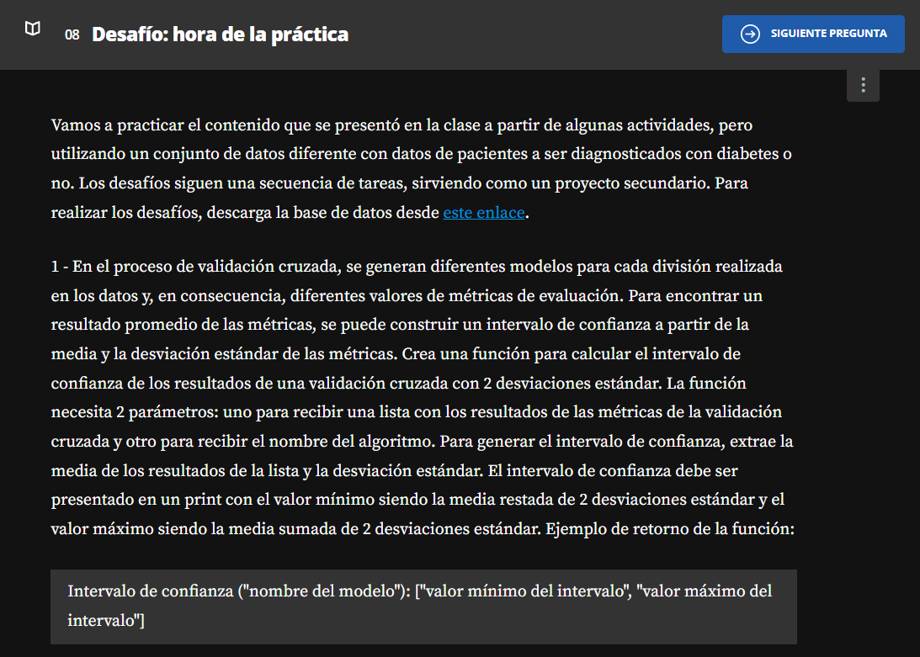

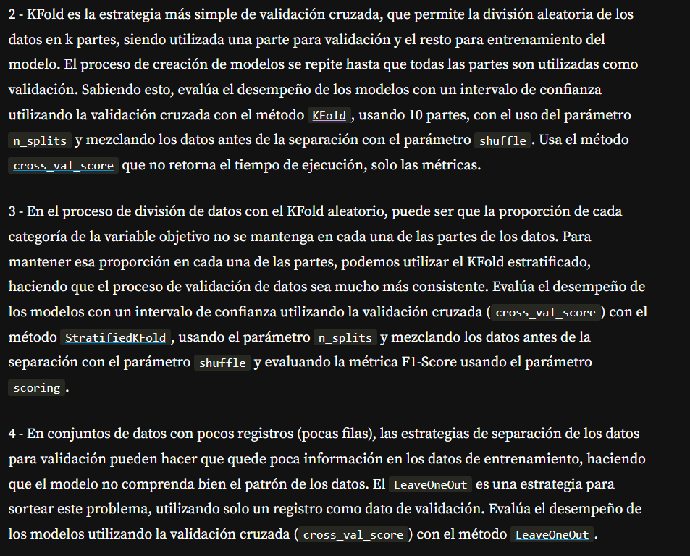

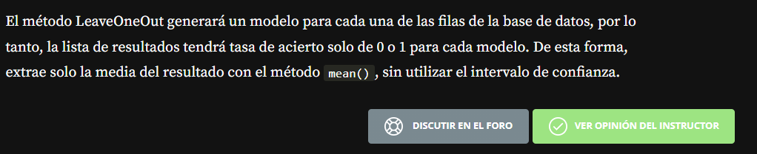

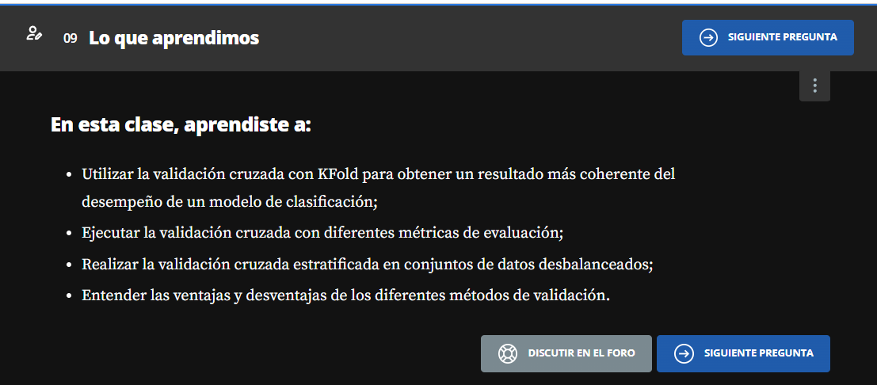

**Balanceo de Datos**

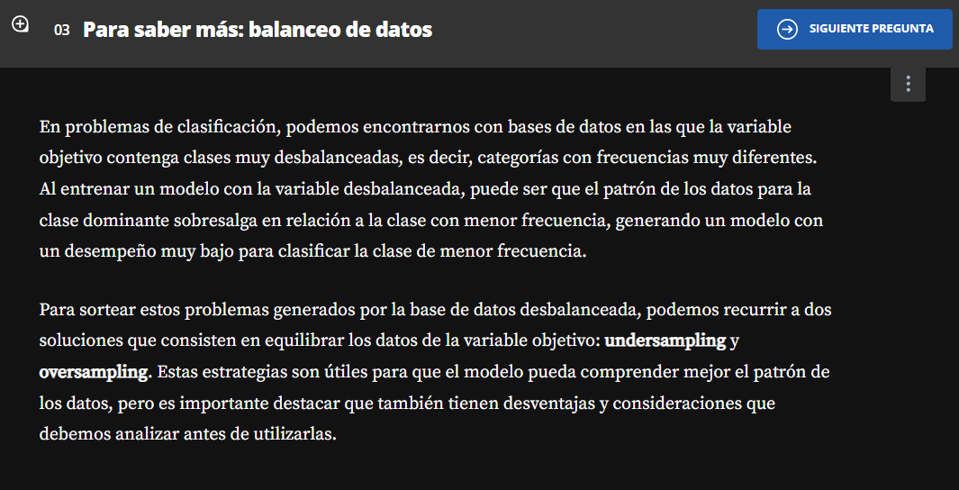

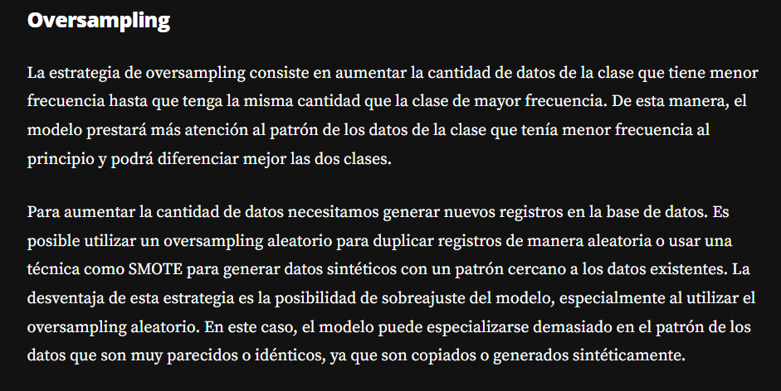

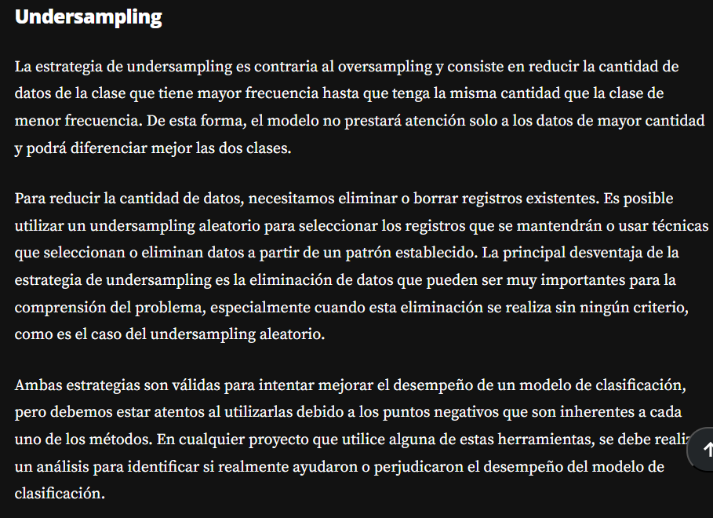

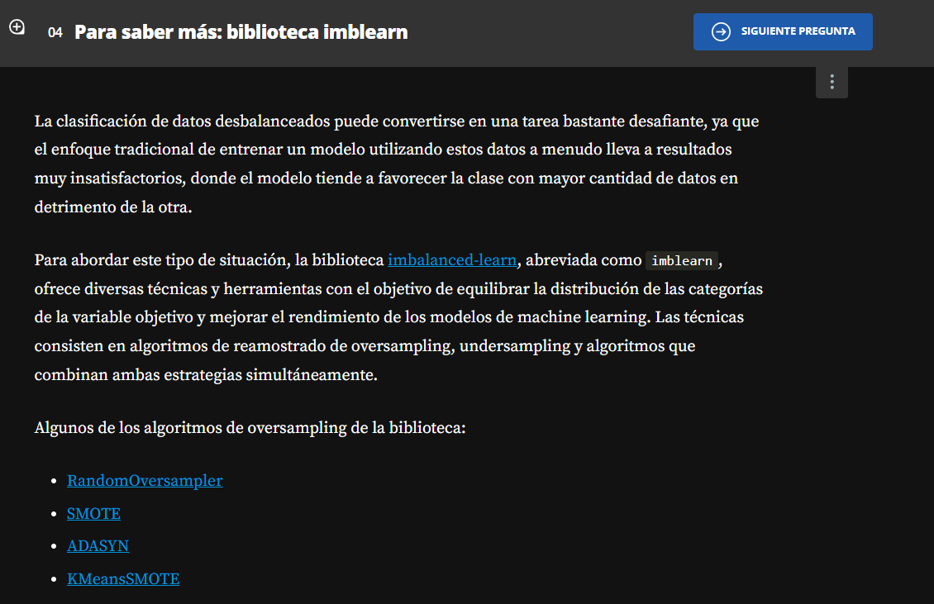

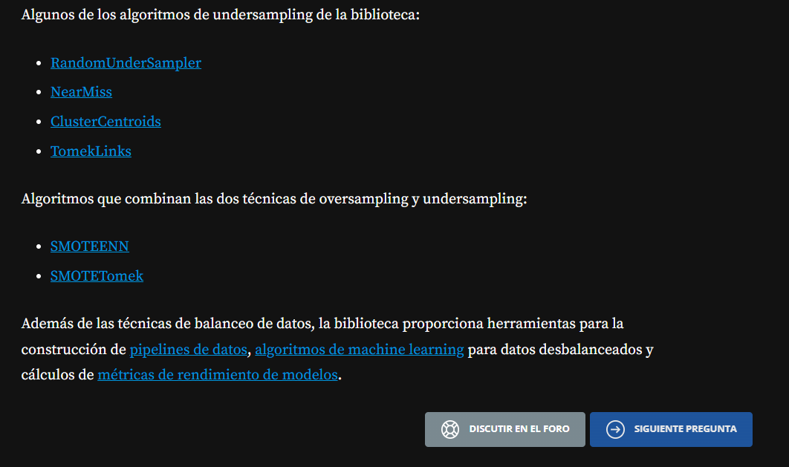

[**https://imbalanced-learn.org/stable/references/generated/imblearn.over_sampling.RandomOverSampler.html**](https://imbalanced-learn.org/stable/references/generated/imblearn.over_sampling.RandomOverSampler.html)

[**https://imbalanced-learn.org/stable/references/generated/imblearn.over_sampling.SMOTE.html**](https://imbalanced-learn.org/stable/references/generated/imblearn.over_sampling.SMOTE.html)

[**https://imbalanced-learn.org/stable/references/generated/imblearn.over_sampling.ADASYN.html**](https://imbalanced-learn.org/stable/references/generated/imblearn.over_sampling.ADASYN.html)

[**https://imbalanced-learn.org/stable/references/generated/imblearn.over_sampling.KMeansSMOTE.html**](https://imbalanced-learn.org/stable/references/generated/imblearn.over_sampling.KMeansSMOTE.html)

[**https://imbalanced-learn.org/stable/references/generated/imblearn.under_sampling.RandomUnderSampler.html**](https://imbalanced-learn.org/stable/references/generated/imblearn.under_sampling.RandomUnderSampler.html)

[**https://imbalanced-learn.org/stable/references/generated/imblearn.under_sampling.NearMiss.html**](https://imbalanced-learn.org/stable/references/generated/imblearn.under_sampling.NearMiss.html)

[**https://imbalanced-learn.org/stable/references/generated/imblearn.under_sampling.ClusterCentroids.html**](https://imbalanced-learn.org/stable/references/generated/imblearn.under_sampling.ClusterCentroids.html)

[**https://imbalanced-learn.org/stable/references/generated/imblearn.under_sampling.TomekLinks.html**](https://imbalanced-learn.org/stable/references/generated/imblearn.under_sampling.TomekLinks.html)

[**https://imbalanced-learn.org/stable/references/generated/imblearn.combine.SMOTEENN.html**](https://imbalanced-learn.org/stable/references/generated/imblearn.combine.SMOTEENN.html)

[**https://imbalanced-learn.org/stable/references/generated/imblearn.combine.SMOTETomek.html**](https://imbalanced-learn.org/stable/references/generated/imblearn.combine.SMOTETomek.html)

[**https://imbalanced-learn.org/stable/references/pipeline.html**](https://imbalanced-learn.org/stable/references/pipeline.html)

[**https://imbalanced-learn.org/stable/references/ensemble.html**](https://imbalanced-learn.org/stable/references/ensemble.html)

[**https://imbalanced-learn.org/stable/references/metrics.html**](https://imbalanced-learn.org/stable/references/metrics.html)

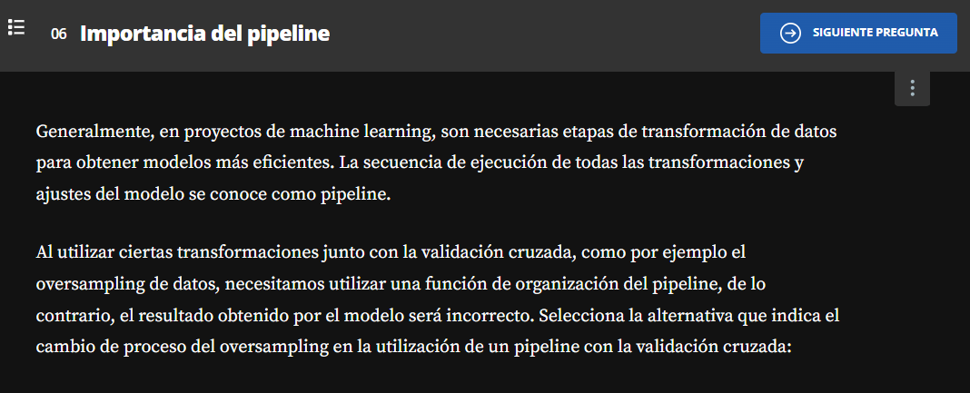

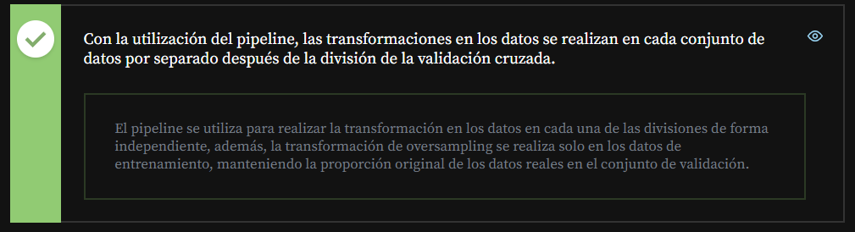

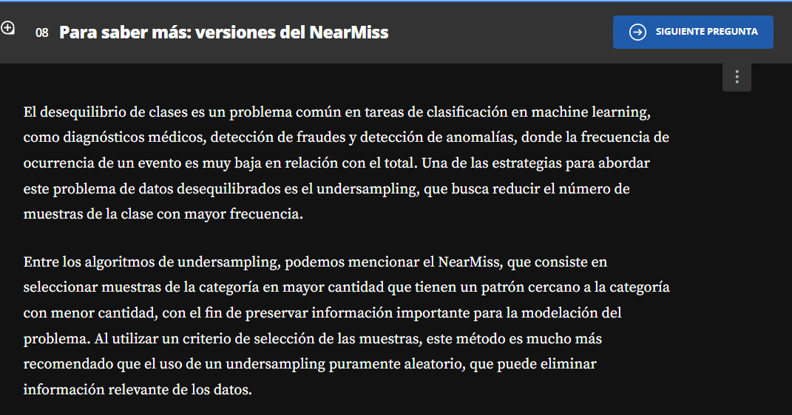

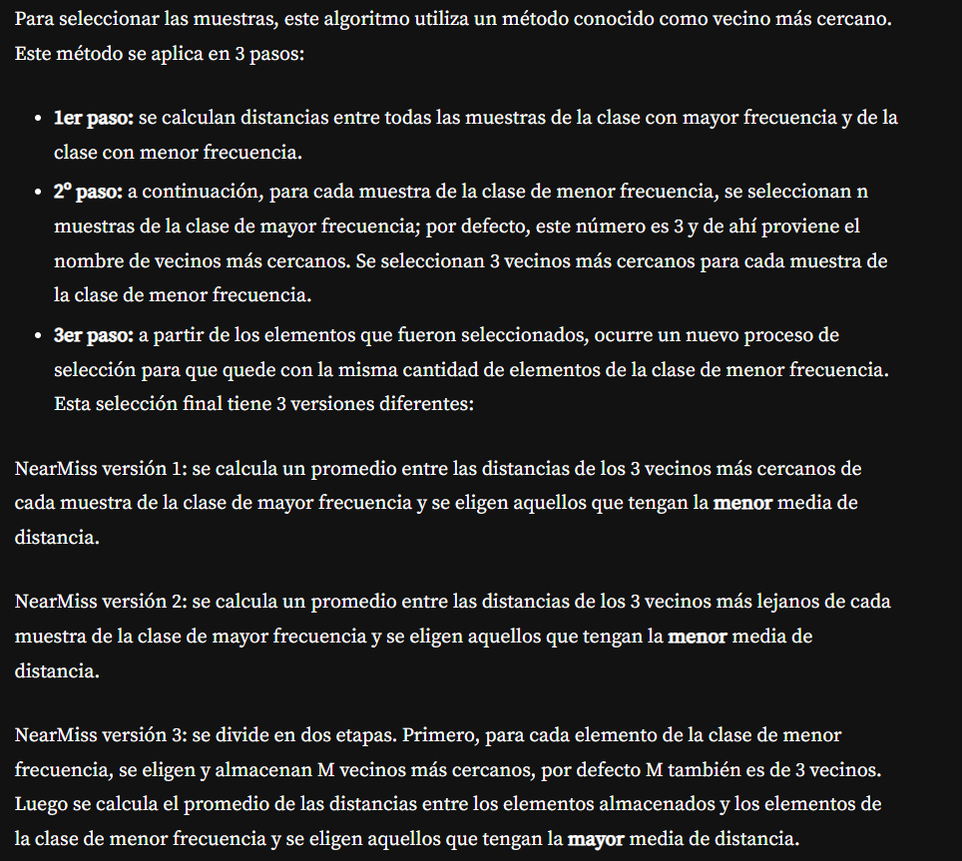

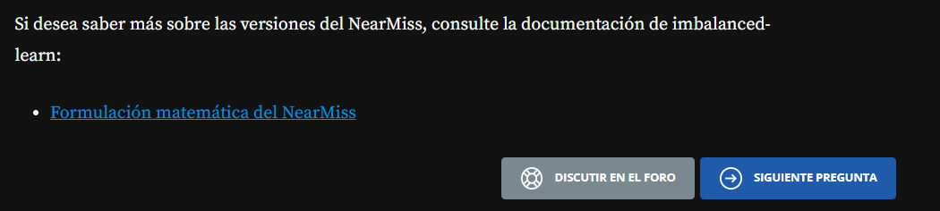

[**https://imbalanced-learn.org/dev/under_sampling.html#mathematical-formulation**](https://imbalanced-learn.org/dev/under_sampling.html#mathematical-formulation)

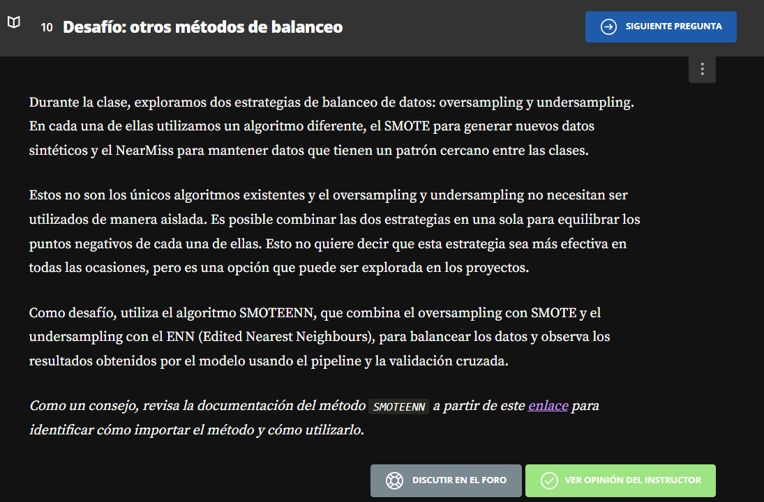

[**https://imbalanced-learn.org/stable/references/generated/imblearn.combine.SMOTEENN.html**](https://imbalanced-learn.org/stable/references/generated/imblearn.combine.SMOTEENN.html)

